Que 1) Plot a histogram,

10, 13, 18, 22, 27, 32, 38, 40, 45, 51, 56, 57, 88, 90, 92, 94, 99

**ANS:-**

**By using the python we can plot the histogram here is the python code:-**

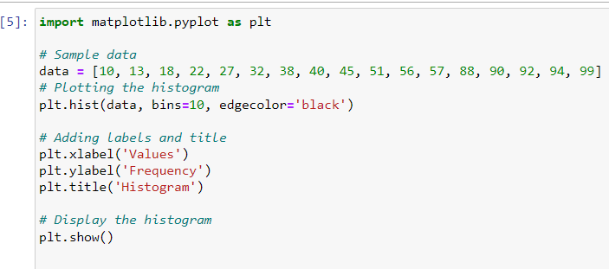

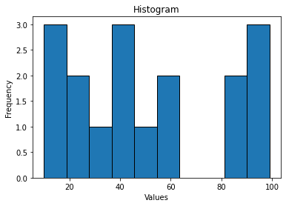

Que 2) In a quant test of the CAT Exam, the population standard deviation is known to be 100. A sample of 25 tests taken has a mean of 520. Construct an 80% CI about the mean.

**ANS:- 𝛔 = 100**

**n=25**

**x bar = 520**

**CI=80%**

**80% CI about the mean = x bar ±Z𝛂/2(𝛔/)**

**= 520Z10() [Z10=1-0.1 =0.90]**

**80% CI about the mean = 520Z10()**

**= 520 1.29(20)**

**= (494.2,545.8)**

**So, 80% CI about the mean is (494.2, 545.8)** 

Que 3) A car believes that the percentage of citizens in city ABC that owns a vehicle is 60% or less. A sales manager disagrees with this. He conducted a hypothesis testing surveying 250 residents & found that 170 residents responded yes to owning a vehicle.

1. State the null & alternate hypothesis.
2. At a 10% significance level, is there enough evidence to support the idea that vehicle owner in ABC city is 60% or less.

**Ans:- a)**

**H0: 𝛍≥60%**

**H1: 𝛍<60%**

**b)**

**𝛂=0.1**

**p0= 0.6**

**p cap(sampled proportion)= 170/250=0.68**

**Z= (0.68-0.60)/($\sqrt{(0.60(1-0.60)/250)})$** 

**Z** **=2.313**

**By using one-tail test**

**1-0.1=0.9**

**So, at 2.313 value Z score is -1.96**

**-1.96<2.313**

**So, we have enough evidence to reject the null hypothesis i.e. the percentage of a person owns vehicle is less than 60%**

Que 4) What is the value of the 99 percentile?

2,2,3,4,5,5,5,6,7,8,8,8,8,8,9,9,10,11,11,12

**Ans:- rank = percentile*(n+1)/100**

**=99*21/100**

**=20.79**

**20.79th index which is not in a range**

**So we can consider as rank at 20th position is 11 and 21th position is 12**

**Interpolated value = 11+(20.79-20)*(12-11)**

**= 11.79**

**So, the 99th percentile is 11.79(approx.)**

Que 5) In left & right-skewed data, what is the relationship between mean, median & mode?

Draw the graph to represent the same.

**Ans:-**

**In left skewed distribution:- Mean <median< mode**

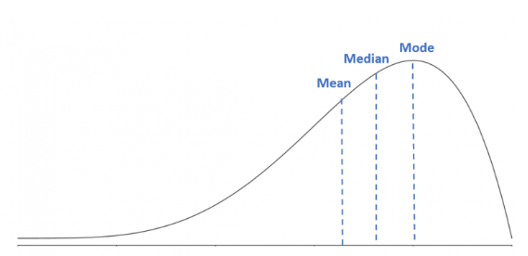

**In right skewed distribution:- mode<median<mean**

